**Unit III**

1. Give the differences between sequence control, decision control and looping control statements. Give example.

Ans: control statements help to jump control from one part of the program to another.

* Sequence control: Normally instructions in the program are executed in the same order in which they appear in the program
* Decision control: In some cases, we need to execute a set of instructions based on certain criteria. This way of controlled execution of statements can be achieved by using decision statements in the program.
* Looping control statements:they are used to repeat the execution of a sequence of statements (statement block) as long specified condition remains true.

1. Elaborate the working of If-Else statement in C with syntax and Example

Ans:

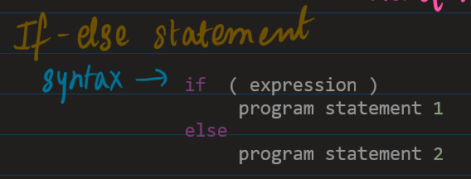

example:

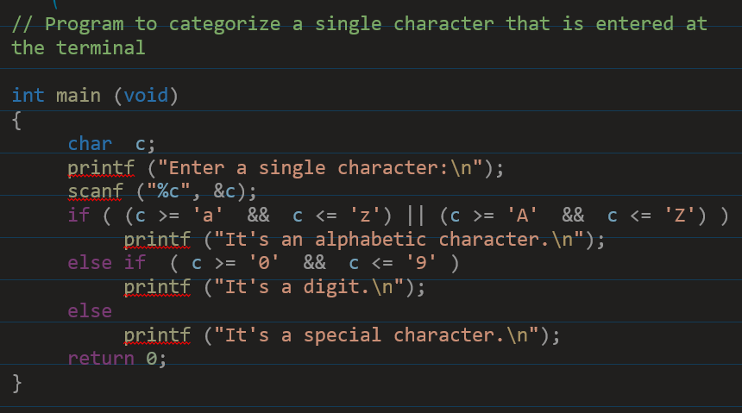

1. Explain the if-else ladder with an example

Ans:

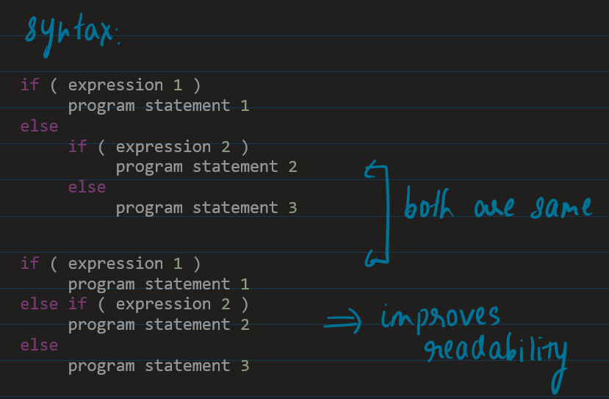

1. What is a ternary operator? Give example

Ans:

1. Give the differences between if-else and switch case

Ans: 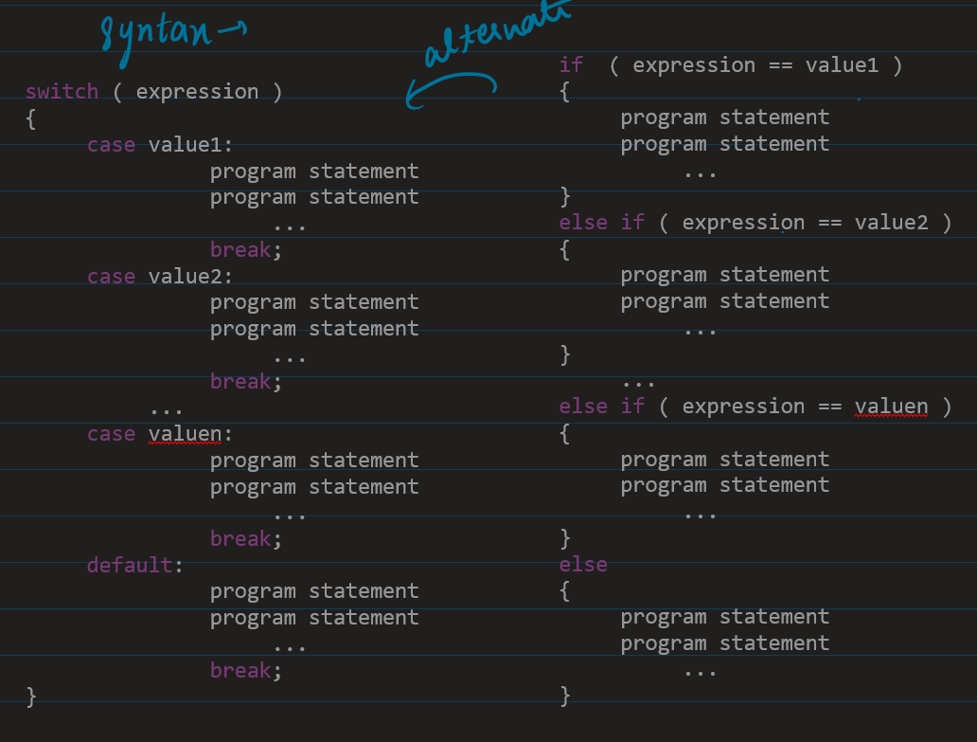

1. With relevant example give the differences between do-while and while loop

Ans:

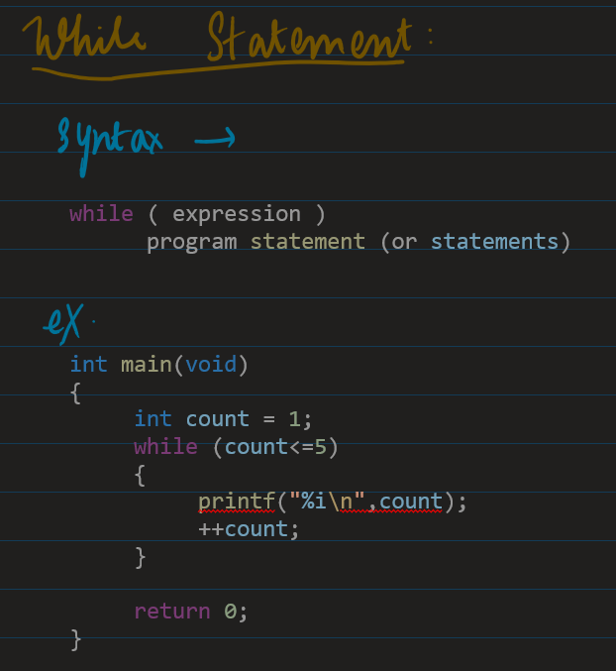

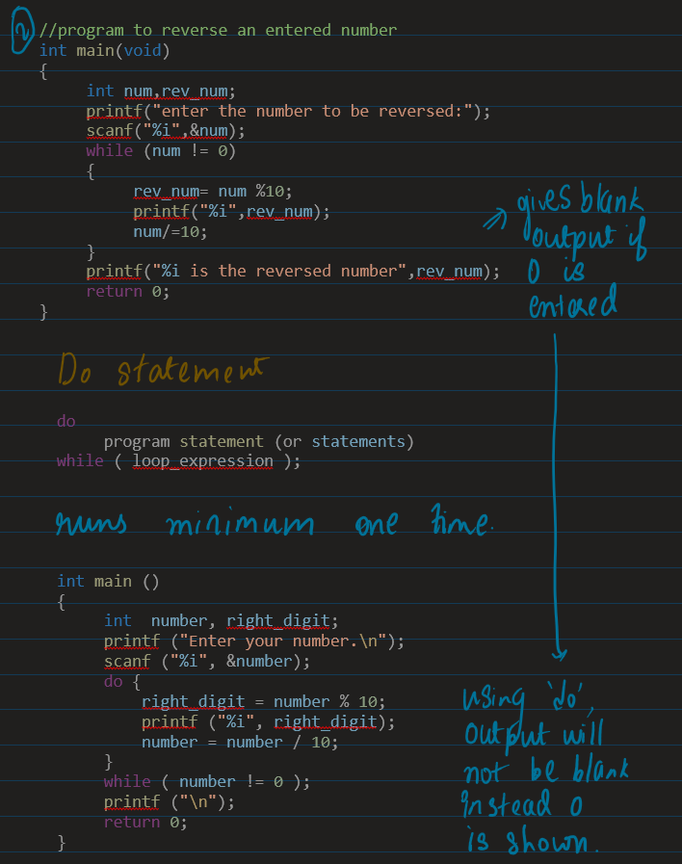

1. Discuss the role of goto, continue and break and detail

Ans:

* break is used to terminate the loop prematurely in which it appears.
* continue is used to skip the iteration in the loop based on the condition.
* goto is used for unconditional transfer of control from goto statement to a labelled statement in the program.

1. What are the different looping structures in C? Give examples

Ans: 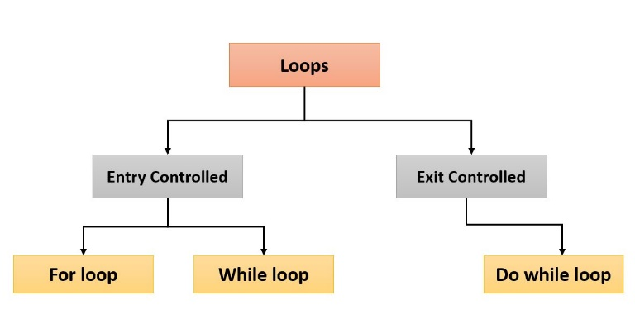

1. Summarize the differences between Entry controlled and Exit controlled loop

Ans:

* Key difference between entry controlled Loop and exit controlled Loop is that
* Entry loop, loop block won’t execute if test expression returns false.
* Exit loop, loop block will be executed even though test expression returns false.

Definite loop: when no of iterations is known. Eg: for loop

Indefinite loop: when no of iterations is not known. Eg: while, do while.

1. Explain the working of nested for loop in detail

Ans:

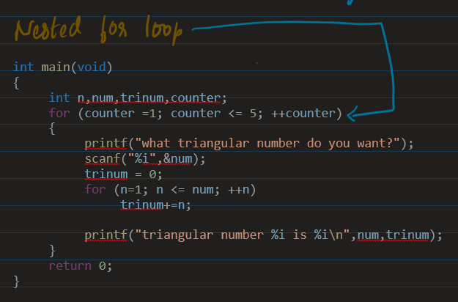

1. Define an array? How do you declare and initialize a one-dimensional array in C?

Ans:

* It is a collection of similar data elements, and all have the same data type.
* The elements of the array are stored in consecutive memory locations and are referenced by an index (subscript).
* Declaring an array: int marks[10];
* Initializing array elements: int marks[5] = { 25, 99, 76, 54, 88 }
* Access the elements of an array:
  + int i, marks[10];
  + for (i=0;i<10;i++)

marks[i] = -1;

1. Explain the working of two-dimensional arrays with an example

**# Relevant programming examples to be practised**